Civil war in Sierra Leone

UNSC Resolution: | 1245
Date of adoption: | 11 June 1999
Operative paragraph: | 3
Demand number: | 1

Megan MacKenzie

Wording of demand
remain committed to the process of negotiation and demonstrate flexibility in their approach to the process

List of addressees of the demand

Government of Sierra Leone, Revolutionary United Front

Short-term compliance

Description of the addressee(s)’ conduct
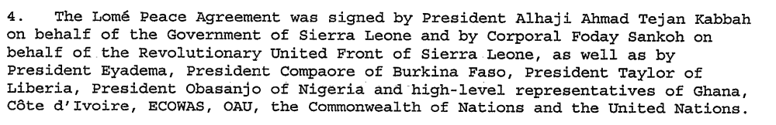
Sierra Leone's rebels have reached a peace agreement with Freetown to share power in a national unity government. "An agreement has been reached," said the source in the Togolese capital, who asked not to be named.
For more than a month, Revolutionary United Front (RUF) rebels have held peace talks here with President Ahmad Tejan Kabbah's government.

Assessment

Short-term compliance
No or marginal compliance (1) | Medium low compliance (2) | Medium high compliance (3) | x Full or almost full compliance (4)

Considerations underlying the assessment

This was a very positive period of time. The dialogue between RUF and the Government of Sierra Leone resulted in the signing of a significant peace agreement.

Medium-term compliance

Description of the addressee(s)’ conduct

Sierra Leone's rebel Revolutionary United Front say they will fight rather than negotiate unless their leader, Foday Sankoh, is released.
Mr Sankoh was captured by Sierra Leone police in the capital on Wednesday - a week after he fled his Freetown home when rebels shot and killed 19 people protesting at the capture of UN peacekeepers… Mr Massakoi [RUF spokesman] told the French AFP news agency: "We will answer force with force and dialogue with dialogue.
"We want to go back to the negotiating table to make sure that all parties comply with what they signed."
Mr Massakoi said the RUF was committed to the 1999 Lome peace accord, which granted rebels full amnesty for horrific atrocities committed during the brutal eight-year civil war, and gave their leader vice-presidential status in a power-sharing government.
7. The Government of Sierra Leone has established its own indirect contacts with RUF, primarily through traditional leaders and relatives. However, the slow pace at which RUF is implementing aspects of the Abuja Agreement, which were intended to build confidence and pave the way for a political dialogue, has not helped to remove the deep apprehension about the rebels’ intentions.

Assessment

Medium-term compliance
No or marginal compliance (1) | x Medium low compliance (2) | Medium high compliance (3) | Full or almost full compliance (4)

Considerations underlying the assessment
The Government of Sierra Leone remained committed to the Lome accord; however, the RUF clearly violated the agreement and did not behave as if they were committed to peace. There were only piecemeal efforts made by the RUF to work towards peace during this period and ultimately the parties were forced to enter a new peace agreement.

Depth of demand

Assessment

Level of depth of demand
Low depth of demand (1) | x Medium depth of demand (2) | High depth of demand (3)

Considerations underlying the assessment

Remaining committed and flexible are two distinct demands that assume a higher level of dedication than dialogue. It implies that the parties must be willing to alter their behavior or expectation in order to facilitate the peace process.

Level of confidence about coding decisions

Level of confidence about coding decision
Extremely high | High | x Moderate

Comments to IPI (if any)

United Nations Secretary General Seventh report of the Secretary-General on UNOMSIL, including recommendations on an expanded UNOMSIL presence 30 July 1999
Sierra Leone Rebels Reach an Agreement http://www.int.iol.co.za/?set_id=1&click_id=68&art_id=qw930545700335B245 June 28, 1999 Independent Online (retrieved 12 August 2009)
Rebels Demand Sankoh Release http://news.bbc.co.uk/2/hi/africa/755486.stm 19 May 2000 (retrieve 2 August 2009)
Kofi Annan. Ninth Report of the Secretary-General on the United Nations Mission in Sierra Leone http://www.afrol.com/html/Countries/Sierra_Leone/documents/un_sg_140301.htm 14 March 2001 (retrieved 13 August 2009)

